Writing a review
Studenti třídy 1F měli v minulém týdnu tento DÚ:
Write a review of a short movie (link below) for the web page of our school. The best review will be published there.
The number of words in your text doesn´t have any importance, but the quality of your review is important and basic.
https://vimeo.com/401098593
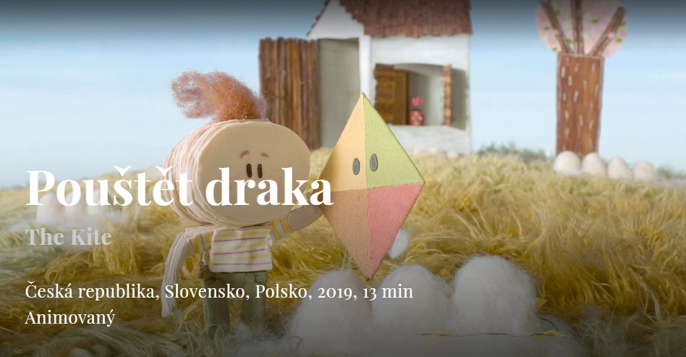
Deadline: Sunday 10th May before 20.00 Mark/grade: A (10)
Enjoy and switch your fantasy & imagination!
A takhle se s tím vypořádali ti nejlepší nebo nejzajímavější, klidně se zamítavými recenzemi:
Aleks
The cartoon tells us about a little boy and his grandfather. A boy visits his grandfather and grandfather gives him a kite. But soon the grandfather dies. The boy still comes to the house where he lived and thanks to the kite donated by his grandfather he remembers him. Moral cartoon lies in the fact that any thing donated by parents is a memory, and that this thing must be carefully stored.

Tereza
I liked the movie from the beginning, I was scared, but the movie fascinated me. What
fascinated me most was how thoughtful my father was going to heaven, how the substance fell out of him over time.
The one who made the film had a great imagination.
I was also surprised that the boy went to heaven to find his dad with the help of a dragon, which I did not expect. The film was well done and I think it's pretty good. The film was also interesting in that everything was made by hand from fabric. He had 13 minutes and it just came to me.
Kateřina
I love the way the movie is made. You can see the movie is
premeditated. The way grandpa gets thinner because he´s old and the
kid´s still got a lot of layers because he´s young... that´s amazing. It´s sad
that his grandfather leaves him, but it´s also very nice how the dragon
gets to see his grandfather so boy can see him again. I really like this
short movie. The characters are very cute and pretty.
Patrik
This short shot is about small boy, who’s loved his grandfather and every day
after school he was coming to his house, which is located on a high hill and
together they were flying a kite. They aren’t an average humans. Their bodies
are made of several layers of some paper-like fabric. Everytime, when one
layer drop, it means that person is closer to his death. Grandfather have only
few layers left, that means, that his time is approaching. One day, the boy
goes to his grandfather again to play together. But something were wrong. His
grandfather was not waiting for him as usual, instead, he found him weak
inside the house. They hand by hand went outside. The huge wind took
grandfather away and now it´s up to the boy to deal with the loss.
This film has it’ unique kind of animation and the plot is that easy and obvious,
that there’s no need to talk there. The makers did a great job, because it’s
really inspirating for kids that someone important for them.
Imelda
I liked the idea of the author but I didn´t understand nor like why he does it with fabrics. It´s a little weird, and the pictures are too immobile, and I also don´t like why his father in the review had several arms. I don´t like anything, it´s really not professional work, it was also a bit touching when his father flew into the sky, which is normal when we are in fabric, paper, cotton clouds, the chairs look real, which gives a strange impression, the little boy who flies away in the clouds and sees his father and swim on cotton clouds is funny, without forgetting the scars of cars (?) which are rolling papers.
Vojtěch
I really liked the art style of this short movie. The choice of not using any words suited the movie very well. The overall message that this movie gives is very inspirational. The movie has a very high quality audio. Animations are very well done.
Andrej
This movie was about a little boy and his grandfather. The boy looked 7-8 years old. He always came by bus to his grandfather to launch a kite. His grandfather lived very far from him in an old house. For boy and his grandpa to launch a kite was a favorite pastime. After school the boy always came to his granddad.
It was winter. The boy came to his grandfather again, but he was no longer in the hut. The boy was very sad. The boy´s dream was to bring back his grandfather and launch a kite together, but this did not happen…
Jakub
The Kite is a short animated film that talks about how a small boy deals with losing his
grandfather. I really liked the child targetted theme with the environment and characters being made out of wool, paper and patchwork. It’s a non-standard animated film with a moral of that even though we can lose all of our loved ones we can still be with them.
Michaela
The boy has a grandfather, whom he often and happily visits. His grandpa gives him a kite, with which they experience a lot of adventures together. His granddad soon died. The boy was unhappy about his grandfather´s death and was still visiting his house. The boy finds a kite in the garden. He remembered his grandpa giving him a kite. Thanks to the kite, he did not forget his grandfather. We understood this video that every thing donated is rare and important. Things from our loved ones we must protect. They are really very valuable.
Grigoriy
I should say that I am not a fan of this kind of videos. Honestly, I do not like everything, what tries to push on my pity, to remind me the thing that members of my family will die. I will think about it when the time cones, but not… While watching video or doing homework. Furthermore, it makes “sense” from nothing. If you want to create something “very philosophical” you should 100% turn to this topic. I can not say that I am angry on this video, I find it cute by the way, but if only I knew what it is going to
be about, I would rather not watch it. In addition, I should notice that I enjoyed the animation. It was awesome, really. Thanks for reading, sorry for my heartless review.

I ostatní studenti prvního ročníku se s tímto zadáním velmi dobře poprali, gratulace a poděkování.
Petr Vlasák, učitel Aj

